Project Proposal

CS 351: Introduction to Database Systems

Quan Wang

3/31/2016

Team Members:

David Ciupei

Tyler Crabtree

Andrew Rosca

Entity Relationship Diagram

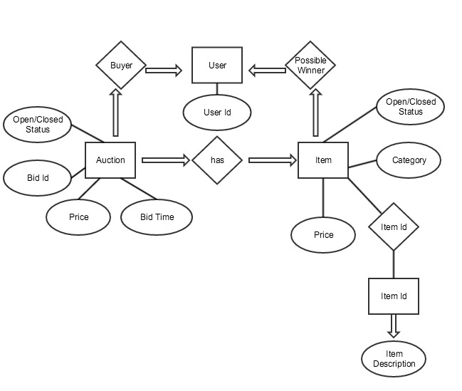

Description: This ER model depicts the layout for a Mini-Ebay system. The ER diagram shows the flow and connection of bids, the user, and items for sale. This diagram for the mini ebay system contains this information:

  item ID

        category

        item description

        price

        open/closed status

the auction's open/closed status

        the auction's bids.

        the name of the bidder (bid id)

        the time of the bid

        the price of the bid

        if the auction is closed

Framework

The framework for the mini ebay system will consist of using webpy, html, and sqlite primarily on Mac OSX. Webpy is a web framework that utilizes Python with a public domain. [Web.py](http://web.py/) 0.37 is the version that the framework will be built on. Html (Hyper Text Markup Language). Html specializes in the formation of web pages. Finally, sqlite is a database management system. The combination of these three language will lay the framework our for the mini ebay system.